**AUTO INDIA RACING CHAMPIONSHIP PUNE**

**2020**

**SEASON- 4**

**Organized by :-**

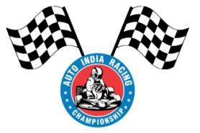

**TEAM NAME** – TEAM TAKSHAK

**TEAM ID** – M200005

**COLLEGE NAME** – JAGADAMBHA COLLEGE OF ENGINEERING & TECHNOLOGY, YAVATMAL, MAHARASHTRA

**FINAL DESIGN REPORT OF INTERNATIONAL GO-KART CHAMPIONSHIP**

**TEAM TAKSHAK**

*Jagadambha College of Engineering. & Technology, Yavatmal, Maharashtra*

*Team ID: M200005*

*Number of member: 23*

**Abstract**

*A mini race car is running and constantly growing concept all over the world. A mini race car is a small four wheeled vehicle used for racing purpose only and run by I.C. engine. A car racing is accepted as most economic form of racing. It is the bridge between theoretical and practical knowledge. We have designed, fabricated and manufactured the mini race car for racing purpose only. This car is powered by Bajaj Pulsar 135 cc engine. The chassis is made of material of steel tubes of AISI 4130 grade. The main objective of car is to make that car with fiscal rate, light in weight and also to increase the performance of car such as speed and efficiency for getting better results in racing. A mini race car must be driven only on racing track. Kart racing or karting is a variant of open-wheel motorsport with small, open, four-wheeled vehicles called karts, go-karts, or gearbox/shifter karts depending on the*

*design. They are usually raced on scaled down circuits. Karting is commonly perceived as the stepping stone to the higher ranks of motorsports, for example Ginetta Juniors, FIA Formula 4, FIA Formula 3, FIA Formula 2 and FIA Formula 1, with former F1 champions such as Nico Rosberg, Ayrton Senna, Lewis Hamilton and Michael Schumacher beginning their careers in karting.Karts vary widely in speed and some (known as Superkarts) can reach speeds exceeding 260 kilometres per hour (160 mph), while recreational go-karts intended for the general public may be limited to lower speeds.*

**1. INTRODUCTION**

We are the team of twenty three students doing B.E Mechanical Engineering in Jagadambha College of Engineering & Technology, Yavatmal. We thank our reputed Institution for giving us this wonderful opportunity to participate in the International Go-kart

Championship 2020-2021 organized by auto India racing championship, Pune. We are greatly indebted and convey our most sincere thanks to our beloved Principal Dr.H.M.Baradkar for providing permission for participating in this competition. We offer our heartfelt gratitude to Dr.V.L.Bhambere, Head of the Department of Mechanical Engineering for his kind patronage in supporting us for participating in competition. We also like to thank our faculty advisor Prof.R.U.Headu , and all the teaching and non teaching staff members of Mechanical Engineering department who have supported us.

We have split our team into seven sub systems to design and manufacture our kart and their corresponding reports and calculations are done as below:

1. Design & Analysis

2. Steering system

3. Brake system

4. Power train and transmission system

5. Electrical system

6. Selection of wheels & tires

7. Innovation plan

**2. COMPLETE TECHNICAL SPECIFICATIONS OF VEHICLE:**

|  |  |
| --- | --- |
| **CONTENTS** | **DETAILS** |
| Overall length | 80” |
| Overall width | 30” |
| Overall height | 36” |
| Front track width | 40” |
| Rear track width | 44” |
| Wheelbase | 48” |
| Ground clearance | 2.25” |
| Gross Vehicle Weight(GVW) | 180 kg |
| FAW | 40% of GVW |
| RAW | 60% of GVW |

TABLE 1

**2.1 DIMENSIONS OF TYRE USED:**

|  |  |  |  |
| --- | --- | --- | --- |
| **CONTENTS** | **OUTER DIAMETER ‘mm’** | **WIDTH ‘mm’** | **INNER DIAMETER ‘mm’** |
| **FRONT** | 10” | 4.5” | 5” |
| **REAR** | 11” | 7.1” | 5” |

TABLE 2

**2.2 PERFORMANCE TABLE:**

|  |  |
| --- | --- |
| Maximum speed | 105kmph |
| Max. Power | 13.56 BHP @ 9000 rpm |
| Max. Torque | 11.4 N-m @ 7500 rpm |
| Steering ratio | 1:1 |
| Turning radius | 2499.2 mm |
| Stopping Distance | 3.0777 m |
| Stopping Time | 1.2820 sec |

TABLE 3

**2.3 DESIGN & ANALYSIS:**

**2.3.1 MATERIAL:**

We are using AISI 4130 carbon steel for our frame because of its high tensile strength, best weld ability, machinability and high toughness.

**2.3.2 PHYSICAL PROPERTIES:**

|  |  |  |
| --- | --- | --- |
| **SR. NO.** | **PROPERTIES** | **VALUES** |
| 1 | Tensile strength, Ultimate | 560Mpa |
| 2 | Tensile strength, yield | 435Mpa |
| 3 | Modulus of Elasticity | 210Gpa |
| 4 | Shear Modulus | 80Gpa |
| 5 | Poisson’s ratio | 0.27-0.30 |

TABLE 4

**2.4 RESULTS OF CHEMICAL ANALYSIS-(in %) :**

|  |  |
| --- | --- |
| **PARAMETER** | **RESULT** |
| Carbon | 0.28 to 0.33% |
| Manganese | 0.4 to 0.6% |
| Phosphorus | 0 to 0.035% |
| Silicon | 0.15 - 0.35% |
| Sulphur | 0 to 0.040% |

TABLE 5

**2.5 CAD MODEL:**

Our frame is designed using CATIA V5 R19 to achieve best optimum geometry with less design errors.

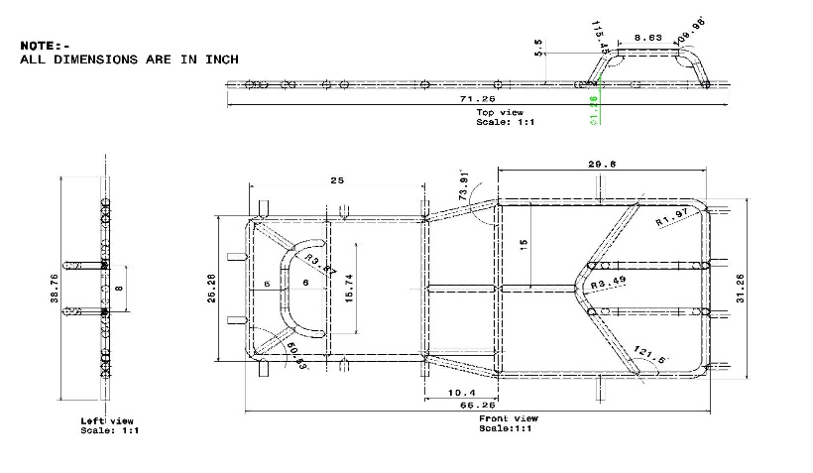

Figure 1. 2D model

**2.6 COMPUTER AIDED ENGINEERING (CAE):**

**FRAME FEA SAFETY ANALYSIS:**

Structural integrity of the frame was verified by comparing the analysis result with the standard values of the material. Analysis was conducted by use of finite element analysis (FEA) on ANSYS WORKBENCH 14.5 software. To conduct finite element analysis of the chassis a CAD model of the designed chassis was uploaded from CATIA V5 R19, the stresses were calculated by simulating different induced load cases.

1. Front impact

2. Rear impact

3. Side impact

4. Four side impact

5. Dynamic load

**PRE-PROCESSING:**

**MESHING:**

No. of Nodes: 89371

No. of Elements: 47139

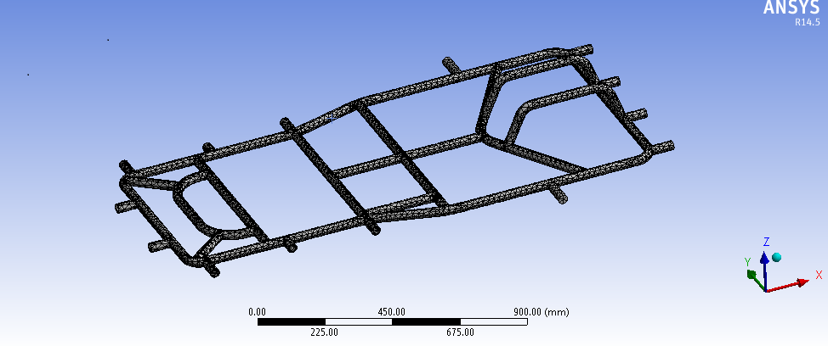 Figure2: Mesh diagram

**INITIAL LOADING CONDITIONS:** 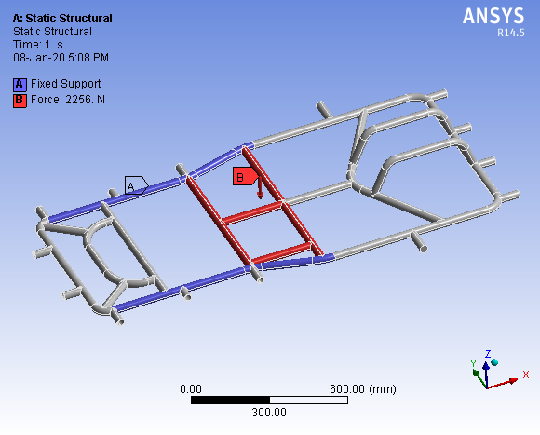

Figure3 : Static load condition

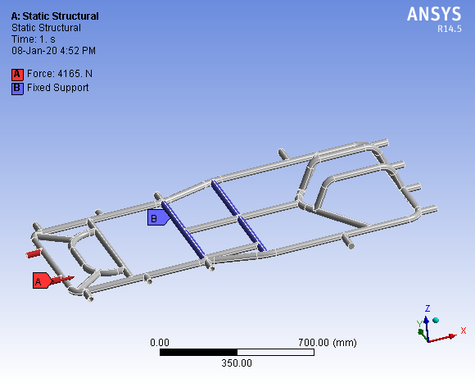

Figure4: Four side loading condition



Figure5: Front load condition

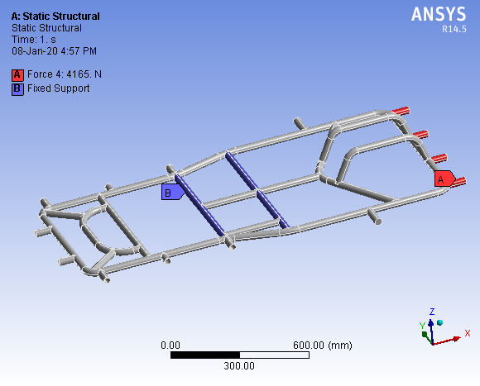

Figure6: Rear load condition

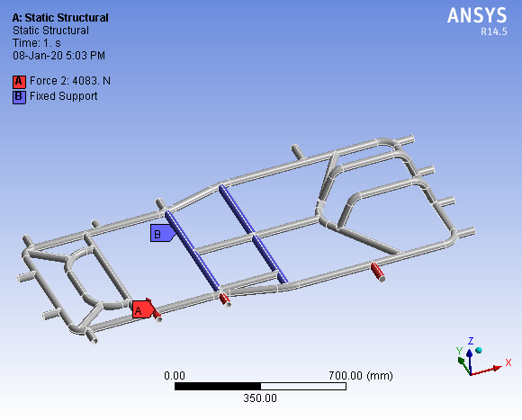

Figure7: Side load condition

**POST PROCESSING:**

Calculations:

The impacts are purely elastic collision and the velocities for the impact tests were taken according to The European New Car Assessment Program (ENCAP).

**FORMULA USED:**

(Impulse momentum theorem – Newton’s 2nd law)

F = m × a

a = (v-u) ÷t

Factor of safety (FOS) = Yield stress / Working stress

Where,

F – Impact force applied on the vehicle

m – Mass of the vehicle (120 + 55 = 175)

a – deceleration (negative acceleration)

u – Initial velocity

v – Final velocity

t – Collision time

**2.7 DYNAMIC LOAD ANALYSIS:**

For the front impact, engine and driver load was given at respective points. The kingpin mounting points and rear wheels position kept fixed. Front impact was calculated for an optimum speed of 90 kmph. The loads were applied at front, back & side of the chassis because application of forces at one end, while constraining the other, results in a more conservative approach of analysis. Time of impact considered is 1.05 seconds as per industrial standards.

**2.7.1 FRONT IMPACT:**

Here we assumed our vehicle to experience the impact force at a speed of 90km/hr. for a collision time of 1.05secs in the front region of our frame by applying constraints at the driver seat.

Since,

a = (90 - 0) / 1.05

= 90 × 1000) ÷ (60 × 60 × 1.05)

= 23.80 m/s2

Therefore,

F = 175 × 23.80

= 4165 N

**TOTAL DEFORMATION**

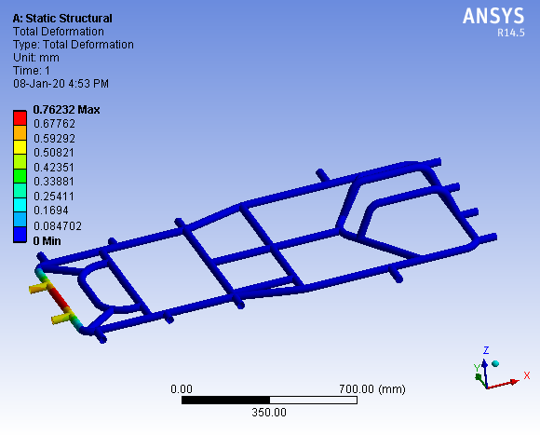

Figure 8. Front impact maximum deflection

Maximum deflection= 0.7623 mm

**EQUIVALENT VON-MISES STRESS**

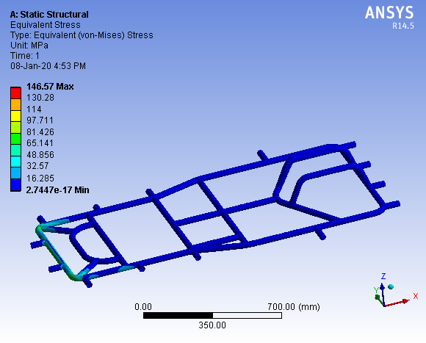

Figure9: Front Impact Equivalent Stress

Maximum stress value = 146.57 MPa

**FACTOR OF SAFETY**:

FOS = yield stress / working stress

= 435 / 146.57

= 2.96

**2.7.2 REAR IMPACT:**

Here we assumed our vehicle to experience the impact force at a speed of 90km/hr for a collision time of 1.05secs in the rear region of our frame by applying constraints at the driver seat.

Since,

a = (90 - 0) / 1.05

= (90 × 1000) ÷ (60 × 60 × 1.05)

= 23.80 m/s2

Therefore,

F = 175 × 23.80 = 4165 N

**TOTAL DEFORMATION**

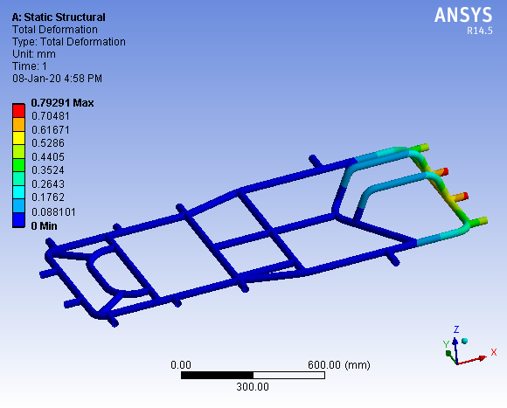

Figure10: Rear impact maximum deflection.

Maximum deflection = 0.79 mm

**EQUIVALENT VON-MISES STRESS**

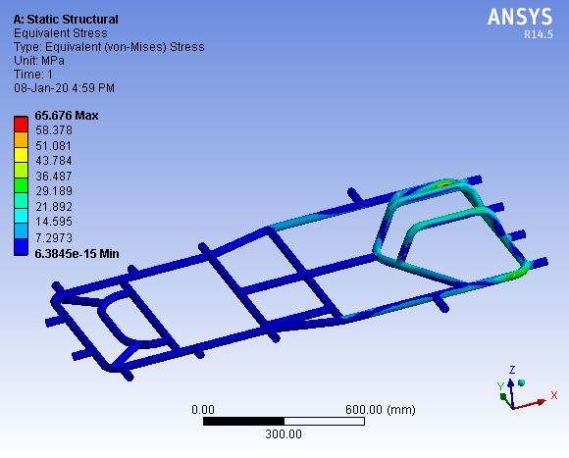

Figure11: Rear impact equivalent stress.

Maximum stress value = 65.67 MPa

**FACTOR OF SAFETY:**

FOS = yield stress / working stress

= 435 / 65.67

= 6.62

**2.7.3 SIDE IMPACT:**

Here we assumed our vehicle to experience the impact force at a speed of 90km/hr for a collision time of 1.05secs in the side region of our frame by applying constraints at the driver seat.

Since,

a = (90 - 0) ÷ 1.05

= (90 × 1000) ÷ (60 × 60 × 1.05)

= 23.80 m/s2

Therefore,

F = 175 × 23.80

= 4165 N

**TOTAL DEFORMATION**

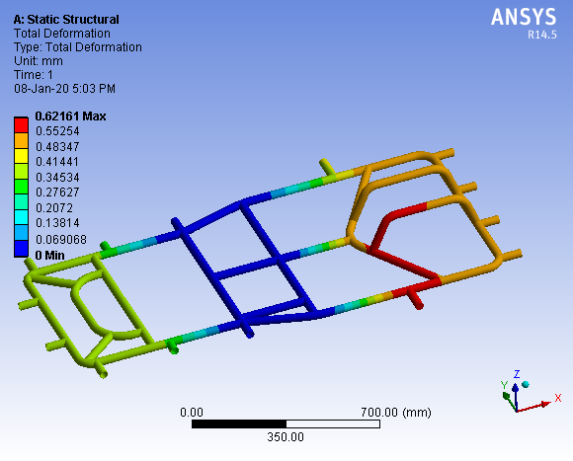

Figure12: Side Impact Maximum Deflection.

Maximum deformation= 0.62 mm

**EQUIVALENT VON-MISES STRESS:**

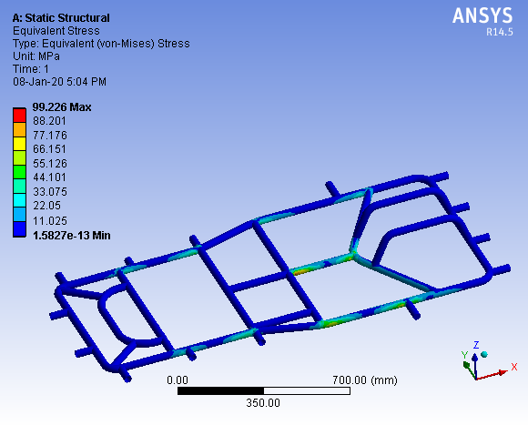

Figure13: Side Impact Maximum Stress

Maximum stress value = 99.22 MPa

**FACTOR OF SAFETY:**

FOS = yield stress / working stress

= 435 / 99.22

= 4.38

**2.7.4 FOUR SIDE ANALYSIS:**

This analysis has been carried out to know the safety characteristics of our frame. So our frame is subjected to forces in four opposite directions at the four ends.

**TOTAL DEFORMATION**

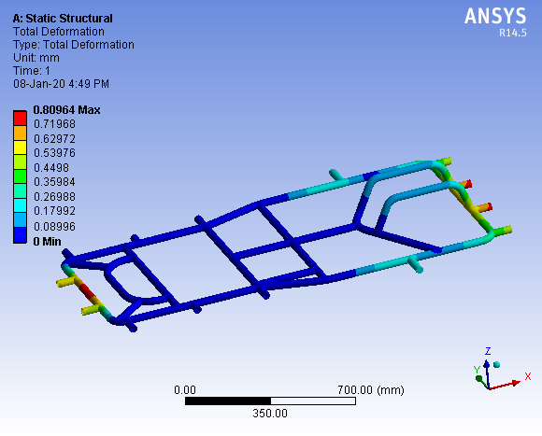

Fig 14: Four side analysis maximum deflection

Total deformation = 0.80 mm

**EQUIVALENT VON-MISES STRESS:**

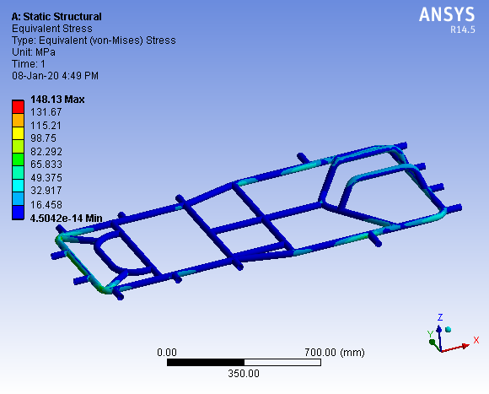

Fig 15: Four side analysis maximum stress

Maximum stress value = 148.13 MPa

**FACTOR OF SAFETY:**

FOS = yield stress / working stress

= 435 / 148.13

= 2.93

**2.7.5 STATIC LOAD ANALYSIS:**

The forces that have been imposed downward to the structural model. The load is distributed uniformly on member below of driver’s seat and engine compartment.

Load applied on the frame is 120Kg of chassis overall weight with all accessories and 55kg of driver.

Here we assume excess value of weight on frame.

Force = 120 + 55

= 175 * 9.81

=1716.75 N

**TOTAL DEFORMATION**

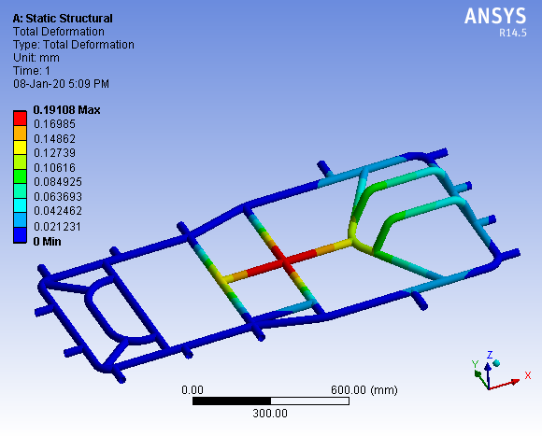

figure16: Static load Impact Maximum Deflection.

Maximum deformation = 0.191mm **EQUIVALENT VON-MISES STRESS:**

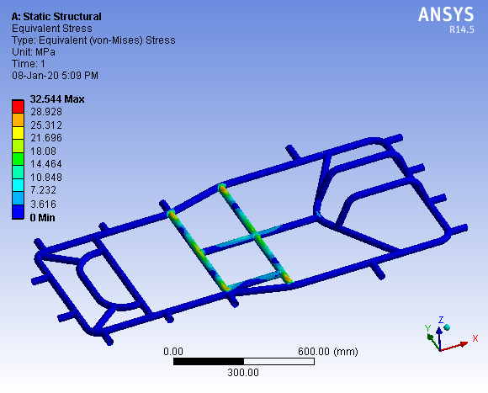

Figure17: Static load impact analysis maximum stress

Maximum stress value = 32.54 MPa **FACTOR OF SAFETY:**

FOS = yield stress / working stress

= 435/ 32.54

= 13.36

**TABULATED RESULT:**

|  |  |  |  |  |
| --- | --- | --- | --- | --- |
| **PARAMETER** | **DEFORMATION (mm)** | **STRESS**  **(MPa)** | **FOS** | **RESULT** |
| Front | 0.76 | 146.57 | 2.96 | Safe |
| Rear | 0.79 | 65.67 | 6.62 | Safe |
| Side | 0.62 | 99.22 | 4.38 | Safe |
| Four sided | 0.80 | 148.13 | 2.93 | Safe |
| Static Load | 0.19 | 32.54 | 13.36 | Safe |

**3.ERGONOMICS AND SAFETY:**

Our kart has been designed to suit the physique of most of the drivers, (i.e.) both stout people as well as average weighing people. The safety measure for driver is considered and the design is done suitably to safeguard the driver and also to meet International standards.

**4. STEERING MECHANISM:**

The steering system is used obviously to turn the go kart in desired direction us the important part is turning the go kart without causing, surging and tire squealing & not loosing control on the go kart.

The geometrical relationship between the go kart line of action and the turn radius are important for a smooth turn and tire wear.

These are many ways of making go kart steering assembly in go kart like ackerman and bogie steering system.

To make the control out go kart easiest & simplest we used steering mechanism of ratio 1:1.

|  |  |
| --- | --- |
| **Components** | **Dimensions** |
| Tie Rod | 14”x0.5” Φ |
| King Pin | 3”x1.5”x11mm Φ |
| Bracket | 3.5”x1.5”x0.5” Φ |
| Bolt | 10mmΦ |
| Steering Shat | 20”x1”Φ |
| Steering Wheel | 10” |

We have use Ackerman steering mechanism. According to its geometry the front wheels will rotate about the mean point which resukted in acting of entire force on outer front wheel on corner

Thus cornering force will be primarily governed by the outer wheel. We have chosen the mechanical linkage because it is cheap, light in weight and easy to manufacture.

|  |  |
| --- | --- |
| Geometry | Values |
| Caster angle | 0o |
| Camber angle | 12o |
| King pin inclination | 10o |
| Combined angle | 10o |
| Toe in | 5mm |
| Scrub radius | 1.5 inches |
| Inner turning radius | 2.1m |
| Outer turning radius | 3.4m |

**4.1.2) STEERING SPECIFICATIONS:**

|  |  |  |
| --- | --- | --- |
| **Sr. No.** | **Parameter** | **Dimensions** |
| 1 | Wheel base | 1219.2 mm |
| 2 | Wheel track | 1041.4 mm (front) 1117.6 mm (rear) |
| 3 | Inner Turning radius | 1998.93 mm |
| 4 | Outer Turning radius | 3197.82 mm |
| 4 | Pivot Centre | 762 mm |
| 5 | Ackerman angle | 29.24˚ |
| 8 | Inner angle | 31.38 ˚ |
| 9 | Outer angle | 21.80˚ |
| 10 | Steering wheel radius | 162.5 mm |
| 11 | Tie rod length | 460 mm |
| 12 | Steering ratio | 1:1 |

**4.1.3) STEERING CALCULATION:**



Figure18: Ackerman steering mechanism

**ACKERMANN ANGLE (α):**

(At 75 % Ackermann, 75% is favorable for slow speed and 25% for high speed.)

75% of wheelbase = 963.3458 mm

Tan α = (a / 2) ÷ (0.75 × b)

Tan α = (1117.6/2) ÷ ( 0.75×1168.4)

α = 39.500

**OUTER ANGLE (φ):**

In triangle ABC, angle C = 90ᵒ.

(Assume Turning Radius (Ro) = 2499.2 mm)

Tan φ = b ÷ (R0 + a/2)

Tan φ = (1219.2 ÷ (2499.2 + 520.7))

φ = 21.980

**INNER ANGLE (θ):**

In triangle ADE, angle E = 90ᵒ.

Tan θ = b ÷ (R0 - a/2)

Tan θ = 1219.2 ÷ (2499.2 – 520.7)

θ = 31.640.

**TURNING RADIUS:**

**a) Inner Turning Radius**

R = b÷ tanθ

= 1219.2÷tan(31.64)

= 1978.68 mm

**b) Outer Turning Radius**

Rmax = b÷sin φ + (a-c÷2)

= 1219.2÷sin21.98 + (1041.4-762÷2)

= 3197.82 mm

**STEERING RATIO: 1:1**

The ratio 1:1 is chosen to achieve less lock to lock angle

**TIE ROD LENGTH:**

Sin α = y ÷ r

Where,

r = radius of the steering wheel

α = Ackermann angle

Sin 39.50 = y ÷ 160

y = 101.77 mm

Lt = c – (Sin α x 2 x y)

Where,

Lt = tie rod length

C = kingpin to kingpin length

Lt = 787.4 – (Sin 39.50 × (2 × 101.77))

Lt = 657.93 mm

**5) BRAKING SYSTEM:**

**5.1 BRAKING PRINCIPLE:**

It goes without saying that brakes are one of the most important control component of vehicle. They are required to stop the vehicle within the smallest possible distance and this is done by converting the kinetic energy of the vehicle into the heat energy which is dissipated into the atmosphere.

**5.2BRAKING REQUIREMENTS:**

1) The brakes must be strong enough to stop the vehicle within a minimum distance in an emergency. But this should also be consistent with safety. The driver must have proper control over the vehicle during braking and the vehicle must not skid.

2) The brakes must have good antipads characteristics i.e. their effectiveness should not decrease with constant prolonged application eg. While descending hills. These requirements demand that the cooling of the brakes should be very efficient.

**5.1 BRAKE SYSTEM SPECIFICATIONS:**

|  |  |  |
| --- | --- | --- |
| SR.NO | CONTENTS & TYPES | SPECIFICATION |
| 1 | Disc Outer Diameter | 170mm |
| 2 | Disc Inner Diameter | 43mm |
| 3 | Disc Thickness | 3mm |
| 4 | Gross Weight Of The Vehicle | 1716.75 N |
| 5 | Pedal Ratio | 4:1 |
| 6 | Break Line Pressure | 12.3887 Mpa |
| 7 | Clamping Force | 19897.0885 N |
| 8 | Rotating Force | 13927.962 N |
| 9 | Braking Torque | 741.663 NM |
| 10 | Coefficient Of Friction | 0.6 |
| 11 | Braking Force | 5393.9127 N |
| 12 | Deceleration | 30.822 m/sec |
| 13 | Stopping Distance | 4.00 m |
| 14 | Braking Time | 1.667 sec |
| 15 | Kinetic Energy | 10800.30 J |
| 16 | Braking Power | 6478.70 N |
| 17 | Area of Master Cylinder | 113.0973 mm2 |
| 18 | Area of Caliper | 804.2777 mm2 |

**5.2 BRAKE CALCULATIONS:**

**1) Weight Distributions:-**

Gross weight of the kart = 175 kg

Front / rear = 2 ÷ 3 = 2:3

Gross Weight of the Vehicle:-

W = weight of the vehicle in kg × 9.81

= 175 × 9.81

W = 1716.95 N

**2) Brake Line Pressure:-**

P = force on the brakes / area of master cylinders

Assume the normal force applied on the pedal=350 N

Pr = pedal ratio × force on pedal ÷ π / 4 × d2

= 4× 350 ÷ π / 4 × (12)2

Pr = 12.3787 Mpa

**3) Clamping Force:-**

Cf = brake line pressure × (area of calliper × 2)

=12.3787 × (π ÷ 4 × (32)2 × 2)

Cp = 19897.0885 N

**4) Rotating Force:-**

Rf = Cf × no. of caliper pistons × coefficient of friction of brake pads

= 19897.0885 ×0.35 ×2

Rf = 13927.962 N

**5) Braking Torque:**

Tn = rotating force × effective disc radius

= 13927.962 × 170+43÷4

=13927.962 × 0.05325

Tn = 741.663 NM

This is the torque available at two tires of rear shaft

**6) Braking Force:-**

Bf = braking torque / tyre radius × efficiency

= 741.663 ÷ 0.11 × 0.8

Bf = 5393.9127 N

**7) Deceleration:-**

Bf = -ma

Negative sign indicates the force in opposite direction

a = -braking force / m

= -5393.9127÷ 175

a = -30.822 m/sec

**8) Stopping Distance:-**

S = v2 – u2 ÷ a

= (11.11)2 ÷ 30.822

S = 4.00 m

**9) Braking Time :-**

t = stopping distance × reaction time ÷ 3.6

3.6 is the fixed fig for converting km/hr to m/sec

t = 4.00×1.5÷3.6

t = 1.667sec

**10) Kinetic Energy:-**

KE = 1 ÷ 2 × mv2

= ½×175× (11.11)2

KE = 10800.30 J

**11) Braking Power:-**

Bp = KE / t

=10800 ÷ 1.667

Bp = 6478.70 N

**12) Area Of Master Cylinder:-**

Amc = π ÷ 4 × D2

D =12mm

Amc = π ÷ 4 × (12)2

Amc = 113.0973 mm2

**13) Area Of Caliper:-**

Ac = π ÷ 4 × D2

D = 32 mm

Ac = π ÷ 4 × (32)2

Ac = 804.277 mm2

**6. POWER TRAIN:**

**6.1 ENGINE & TRANMISSION:**

We Selected Bajaj Pulsar 135 cc Engine 4-stroke petrol With Carburettor and Gravity Fuel system.

**ENGINE SPECIFICATION:**

|  |  |  |
| --- | --- | --- |
| **SR NO** | **DESCRIPTION** | **TYPE** |
| 1 | Displacement | 135 cc |
| 2 | Stroke | 4 stroke single cylinder |
| 3 | Cooling | Air cooled |
| 4 | Max power | 13.56 BHP @ 9000 rpm |
| 5 | Max Torque | 11.4 N-m @ 7500 rpm |
| 6 | Cylinder | Single |
| 7 | Bore | 50 mm |
| 8 | Fuel delivery system | Carburettor |
| 9 | Fuel | Petrol |
| 10 | Ignition | Digital CDI |
| 11 | Transmission Type | Chain Drive |
| 12 | Clutch Type | Wet Multi plate type |
| 13 | No. Of Gears | 5 |
| 14 | Gear Box type | Manual |

**6.2 TRANSMISSION:**

We are using Manual transmission, since it provides required performance and smooth acceleration required for engine. It is simple and also provides better fuel economy and low weight.

**6.3 POWER TRAIN CALCULATION:**

Shaft Diameter: 40mm

Tire Radius: 0.1397m

Tire Diameter: 0.2797m

Final Drive Ratio: 2.28

Engine speed (rpm) = 10×Primary Reduction Ratio ×5th gear ratio ×F×S

**1) For Speed**

S = engine rpm / 10 × p.r.r ×5th Gear ×Final Drive

S = 9000/10×3.9×0.9523×2.28

S =105 km/hr

**2) Working Stress**

Torque at wheel = Engine Torque × Primary Production Ratio ×First Gear Ratio ×Final Drive Ratio

T = 9000×3.9×3.076×2.28

T = 1312.2 N.M

T = Π / 16 × d3× τ

τ = Working stress

312.2 = Π/16× (0.04) × τ

τ = 24844086 N/m2

τ =24.8 N/mm2

Factor of Safety = Mass stress /Working Stress

= 310/24.8

= 12.5

3) **Tractive Force** =U×m×g

U= strees = 0.6×180×9.81

Ft=1059.48 N

4) **Starting Torque** = Ft ×R

= 1059.48 × 0.1397

=148 N m

**7. ELECTRICALS:**

**OBJECTIVE:**

The main objective of the electrical system is to provide electric supply to the electric accessories such as brake light, sensors etc and to control the ignition of the engine. In spark ignition engines, a device is required to ignite the compressed air-fuel mixture at the end of compression stroke. Ignition system fulfils this requirement. It is a part of electrical system which carries the electric current at required voltage to the spark plug which generates spark at correct time. It consists of a battery, switch, distributor ignition coil, spark plugs and necessary wiring.

**CIRCUIT DIAGRAM:**

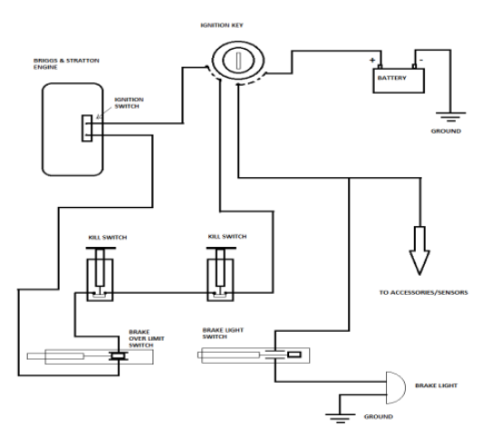

Figure 19: Circuit diagram

**7.1 IGNITION SWITCH:**

The purpose of ignition key is to switch ON the ignition circuit and to switch ON the power supply from the battery to the electric accessories. If the ignition key is turned OFF it reaches the contact in the ignition circuit and power supply from the battery.



Figure 20: Ignition Switch

**7.2 BRAKE LIGHT SWITCH:**

The function of brake light switch is to indicate the people driving behind us that our vehicle is slowing or stopping. Normally the brake light switch is in open contact, whenever the brake pedal is pressed the contacts gets closed and the brake light glows.

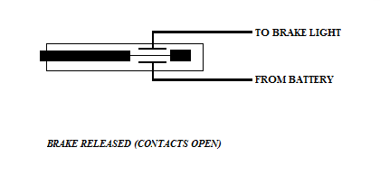

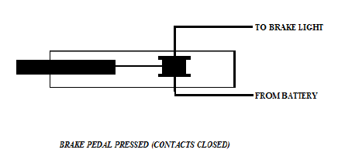

Figure 21: Brake light connection

**7.3 BRAKES OVER LIMIT SWITCH:**

The purpose of brake over limit switch is to cut off the ignition of the engine in case of brake failure in the vehicle. The brake over limit switch is connected in series of ignition key and the kill switches.

**7.4 KILL SWITCHES:**

A kill switch, also known as an emergency stop or e-stop, is a safety mechanism used to shutdown an ignition in an emergency situation in which it cannot be shut down in the usual manner. There are two kill switches. One is placed in the position which is accessible by the driver inside the vehicle and other is in the position which is accessible by volunteers outside the vehicle. These kill switches are connected in series to the brake

Over limit switch and ignition wire.

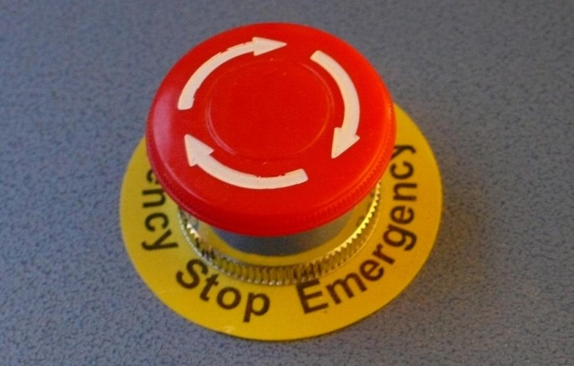Figure 22: Kill switch

**8. INNOVATION PLAN:**

**INTRODUCTION:**

We planned to use the *Hydraulic System* in our Go Kart vehicle which is working under the Ackerman type of steering. Hydraulic add controlled energy to use the steering mechanism, so the driver can provide less effort to turn the steered wheels when driving at typical speeds and reduce considerably the physical effort necessary to turn the wheels when a vehicle is stopped or moving slowly. This steering systems work by using a hydraulic system to multiply force applied to the steering wheel inputs to the vehicle’s steered road wheels. These systems have a direct mechanical connection between the steering wheel and the linkage that steers the wheels. This means that power steering system failure still permits the vehicle to be steered using manual effort alone.

**9. CONCEPT:**

This innovation is fully based on hardware and mechanical arrangement. This system makes the steering of Go Kart more co-operative for the driver which results in the easy and effective turning of the Go Kart vehicle.

**11. WORKING PRINCIPLE:**

The steering system we developed to use is hydraulic type. In the hydraulic system, for the purpose of turning the Go Kart vehicle the arrangement of the two hydraulic cylinder is used. Out of the two cylinders, the first one is situated at the bottom left side of the steering. Fixed by mechanical arrangement in between the tie rod and bottom end of steering rod. Same for the other cylinder which worked on the right bottom side. For the purpose of pressurization there exist liquid in both the cylinders. Both the cylinders are connected with each other with two pipes, which are used for transfer of liquid from one cylinder to other and creating the pressure while turning of vehicle. When we rotate the steering wheel in clockwise direction, the piston will move in outer dead centre of cylinder. Due to this movement, the liquid in the cylinder will get pressurize and get transfer to the second cylinder which is on the other side of piston through pipe. This pressure in the cylinder will helps the turning of vehicle by adding the pressure force in the cylinder and the turning force acted on the steering wheel by driver, which ultimately results in the turning of our vehicle in desired direction.

**13. MERITS:**

1. Create ease in handling of steering and provide directional stability.

2. Low input torque and continuous steering function.

3. Very fast to turn lock to lock without much force.

4. Required low human efforts.

5. Reducing the driver’s fatigue.

6. Better controlling in steering especially at slow speeds, facilitates quicker action.

**14. CONCLUSION:**

The team Takshak has used finite element analysis system to evaluate create and modify the best vehicle design to achieve its set goals. The main goal is to manufacture a kart which is similar to professional karts and at the same time to make it more light weight without sacrificing performance and durability. The result is lighter, faster and more efficient vehicle that improves go-kart design to a new extent. And also finally we thank our Institution and AIRC for giving us this opportunity.